**NAME: TEH YEE XIN**

**MATRIC NO: 278070**

**Exercise 1 – Oriented Object Programing**

|  |
| --- |
| Cattle |
| Attributes:  Breed  Color  Country of origin  Uses |
| eat()  sleep()  walk() |

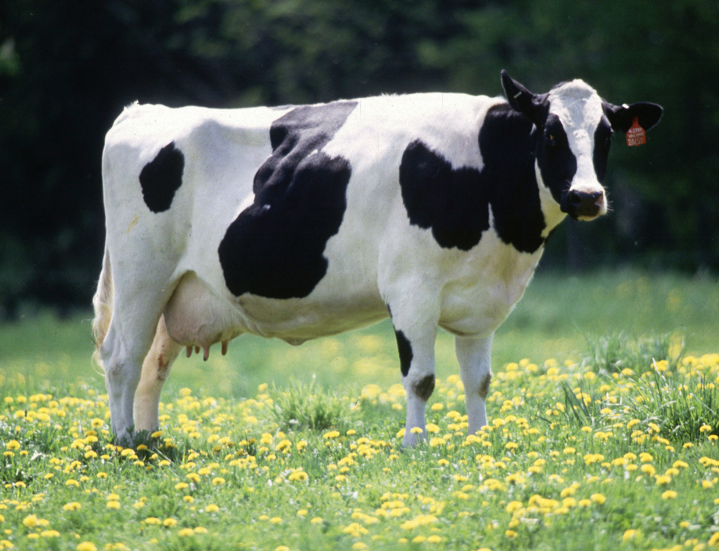 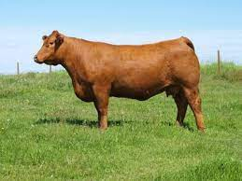 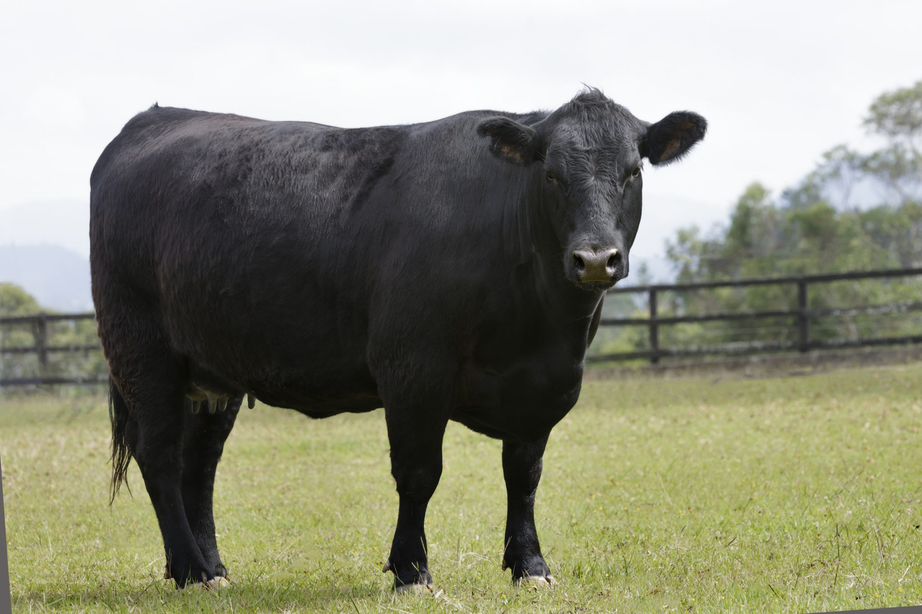

Breed: Agnus cattle

Color: Black

Country of origin: Scotland

Uses: Beef

Breed: Limousin cattle

Color: Gold

Country of origin: France

Uses: Crossbreeding

Breed: Holstein Friesians cattle

Color: Black and white

Country of origin:

Netherlands, Germany, Denmark, Austria, Switzerland, Belgium, France

Uses: Dairy

|  |
| --- |
| Smartphone |
| Attributes:  Brand  Color  Model  Screen size |
| phone call()  send message()  playing game() |

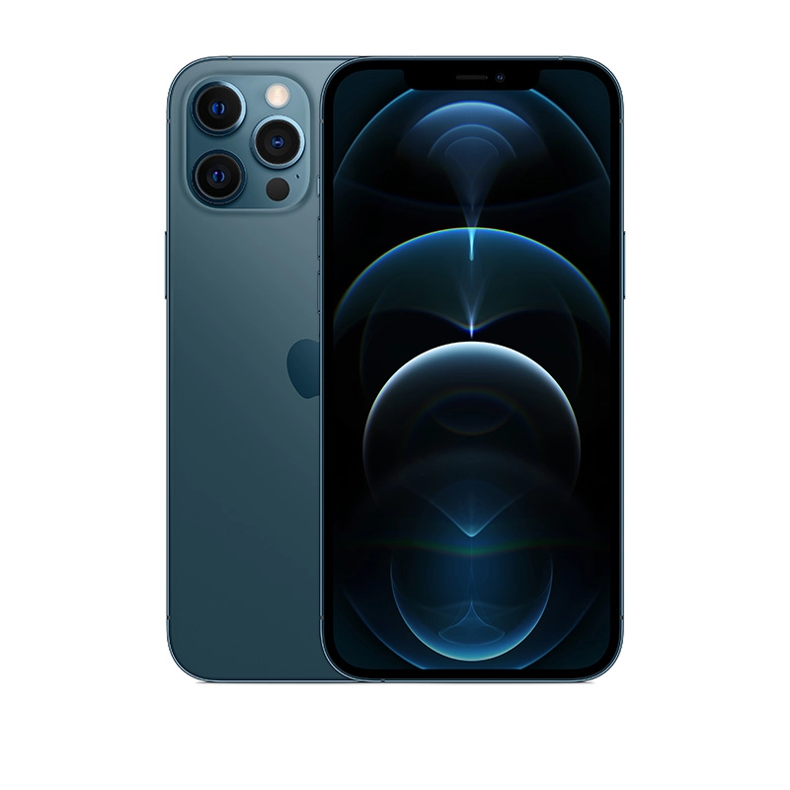 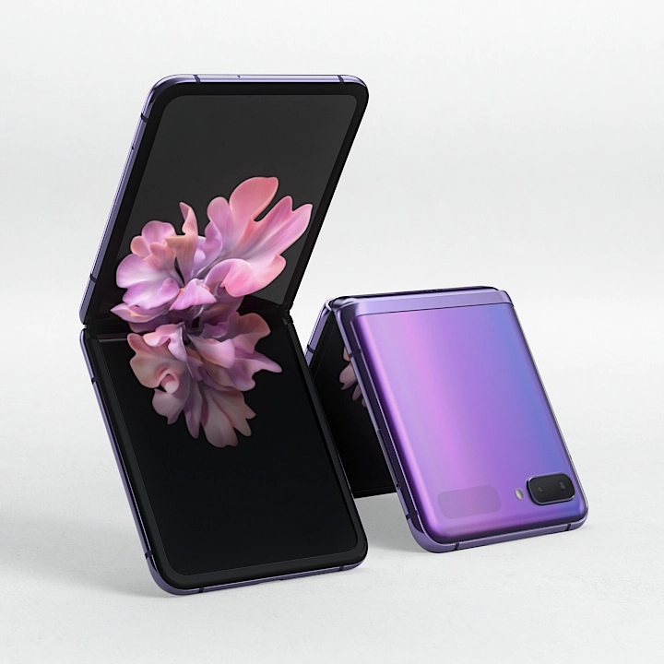 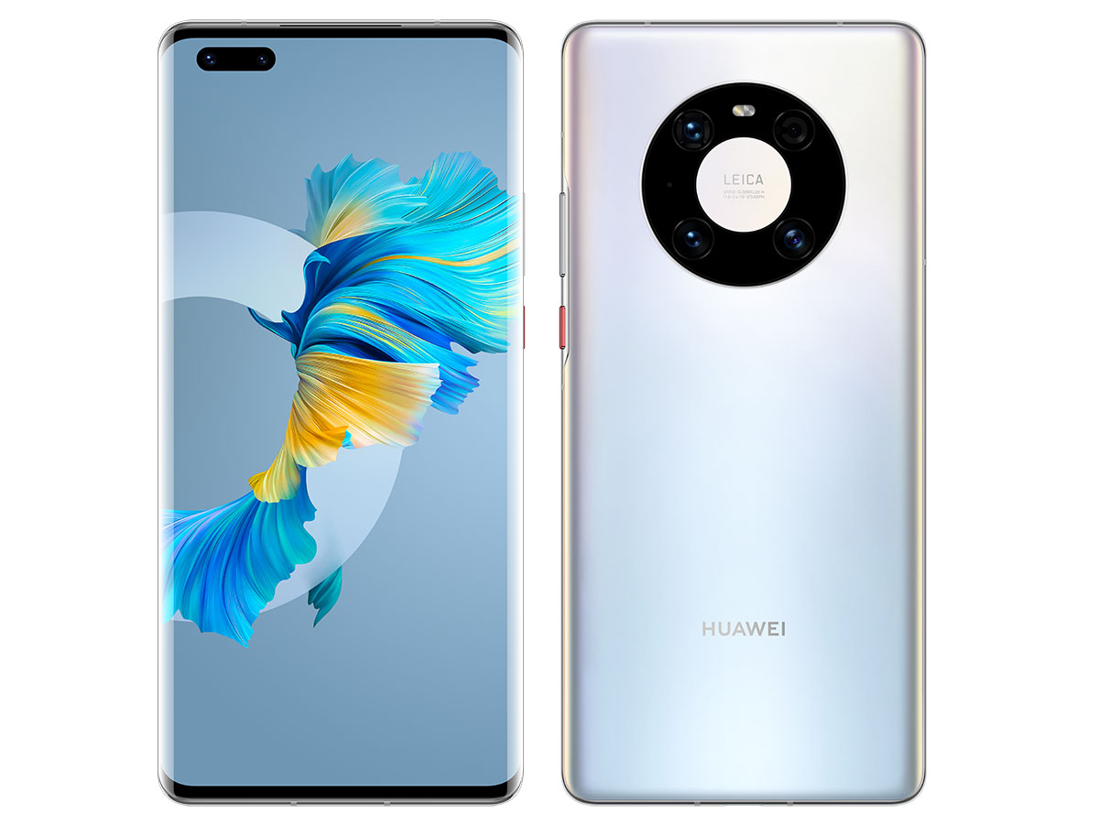

Brand: Huawei

Color: Mystic silver

Model: Huawei Mate 40 Pro

Screen size: 6.76”

Brand: Samsung

Color: Mirror purple

Model: Samsung Galaxy Z Flip

Screen size: 6.7”

Brand: iPhone

Color: Pacific blue

Model: iPhone 12 Pro Max

Screen size: 6.7”

|  |
| --- |
| Multi Cooker |
| Attributes:  Brand  Model  Capacity  Pot material  Power consumption |
| cook rice()  steam()  boiling water() |

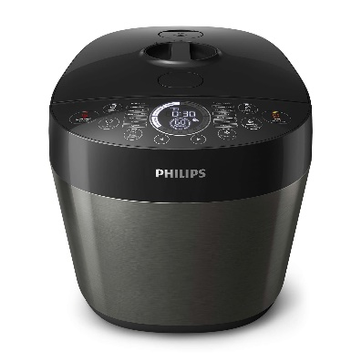 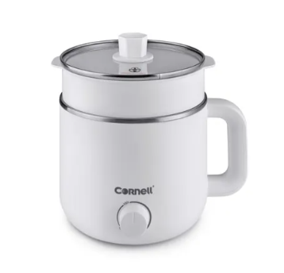 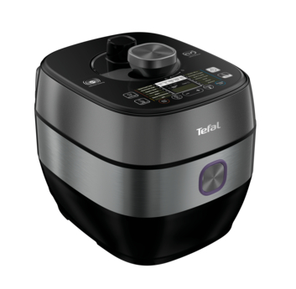

Brand: Tefal

Model: CY638D

Capacity: 5.0L

Pot material: Ceramic Power consumption: 1300W

Brand: Cornell

Model: CMC-S1500X

Capacity: 1.5L

Pot material: Stainless steel

Power consumption: 800W

Brand: Philip

Model: HD2145

Capacity: 6.0L

Pot material: Ceramic

Power consumption: 1000W



|  |
| --- |
| Laptop |
| Attributes:  Brand  Color  Model  Screen  Weight |
| browser()  ()  playing game() |

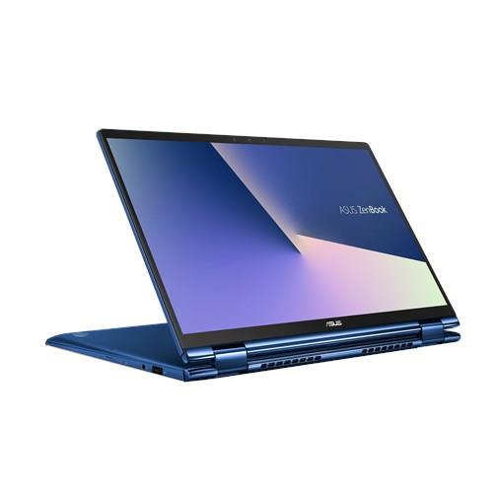 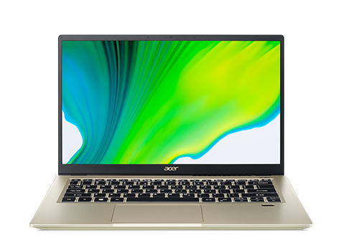 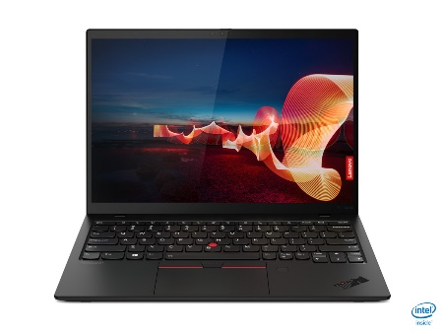

Brand: Lenovo

Color: Black

Model: ThinkPad X1 Nano

Screen: LED Backlight

Weight: 962g

Brand: Acer

Color: Gold

Model: Swift 3X

Screen: FHD IPS screen

Weight: 1.37kg

Brand: Asus

Color: Pine grey

Model: ZenBook Flip 13

Screen: OLED HDR

Weight: 1.3kg

5.

|  |
| --- |
| Bear |
| Attributes:  Breed  Color  Genus |
| eat()  sleep()  crawl() |

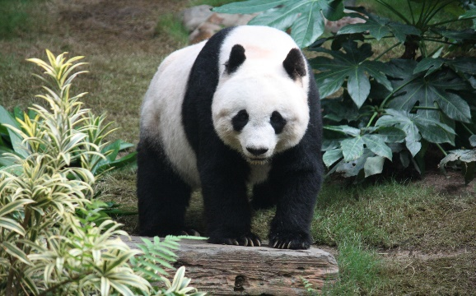 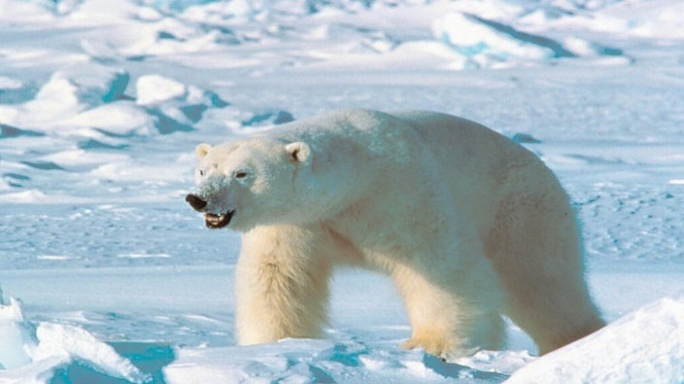 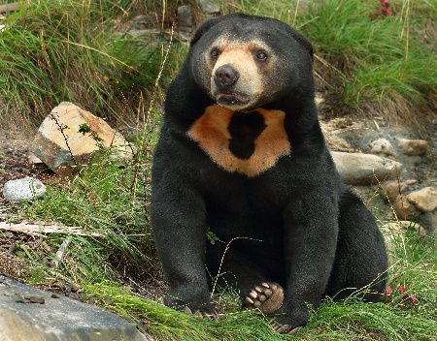

Breed: Sun Bear

Color: Black and orange

Genus: Helarctos

Breed: Polar Bear

Color: White

Genus: Ursus

Breed: Giant Panda

Color: Black and white

Genus: Ailuropoda